Java Ping Checker Laboratory Exercise 4
ITAS 2112 | Unit 4 | Name Kenjhon Dela Cruz Section SD 2-B Date October 16, 2026
Part B: Testing Results Table
Test | Exact input | Resolved IP | Actual result | Interpretation
1. | localhost | 127.0.0.1 | REACHABLE | Confirms that the loopback interface on your local machine is active and responding.
2. | 127.0.0.1 | 127.0.0.1 | REACHABLE | Directly verifies IPv4 loopback connectivity without needing name resolution lookup.
3.
4. | nonexistent.invalid | N/A | Error: Unknown host 'nonexistent.invalid'. The name could not be resolved. | Demonstrates a name resolution (DNS) error when a domain does not exist.
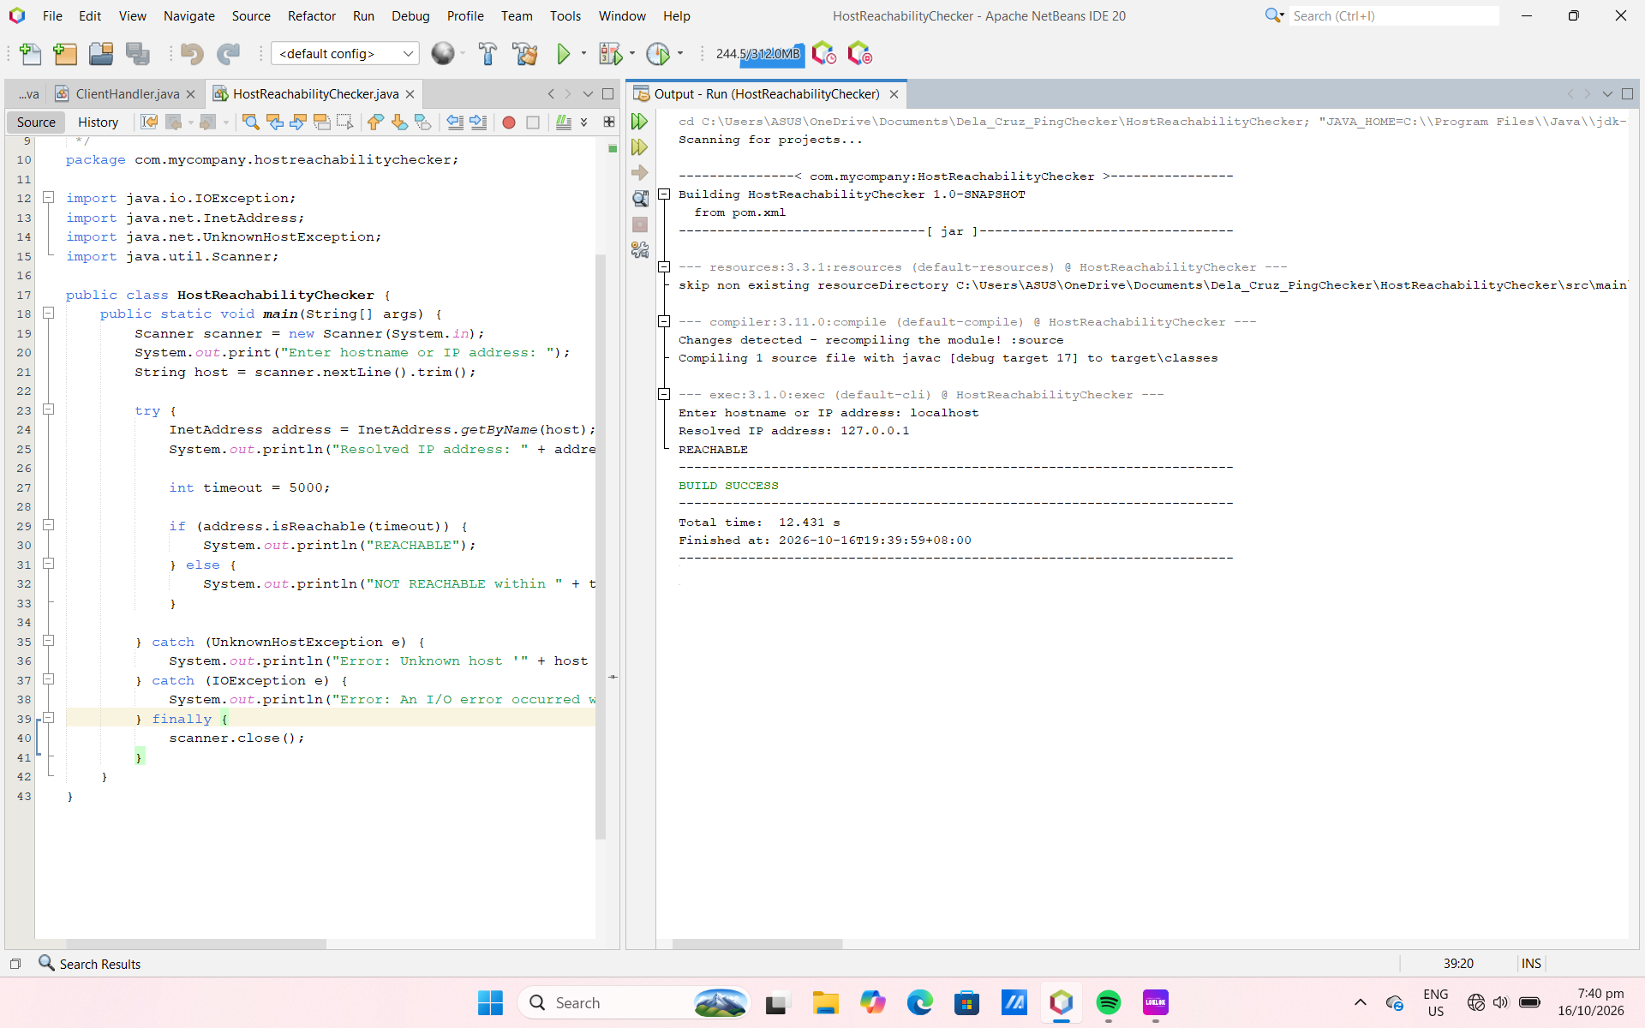
TEST 1
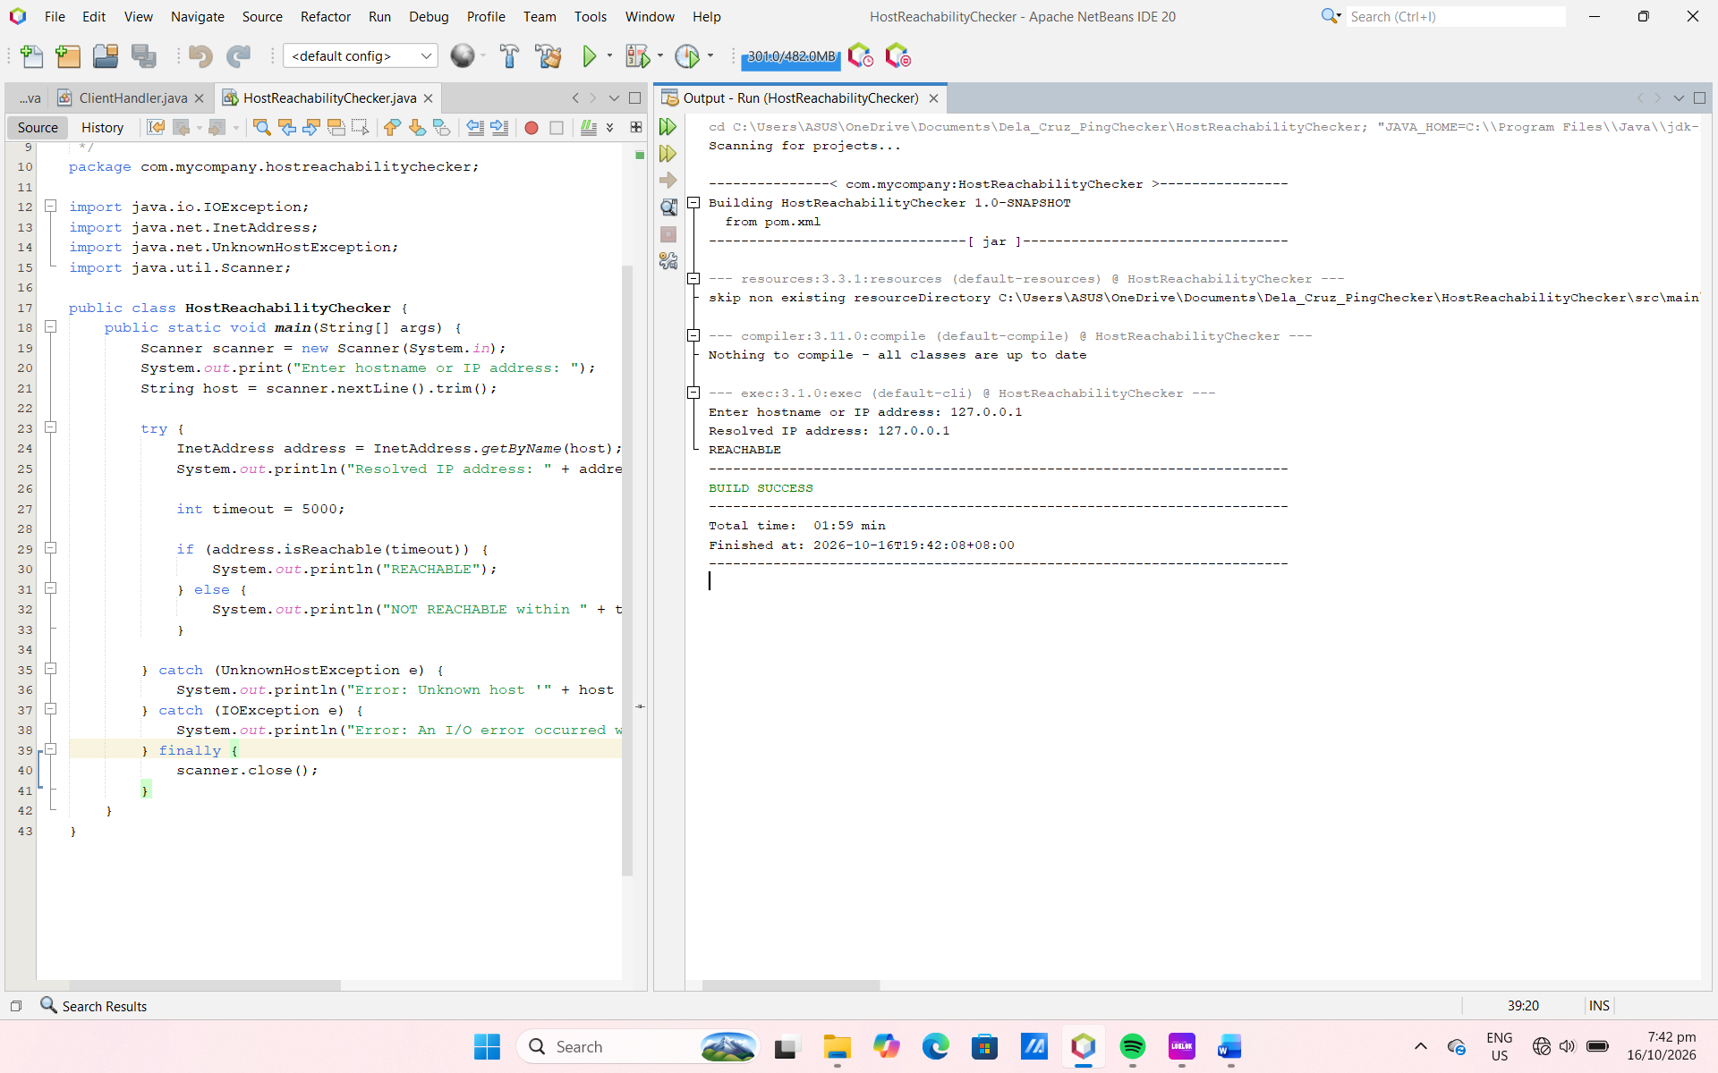
TEST 2
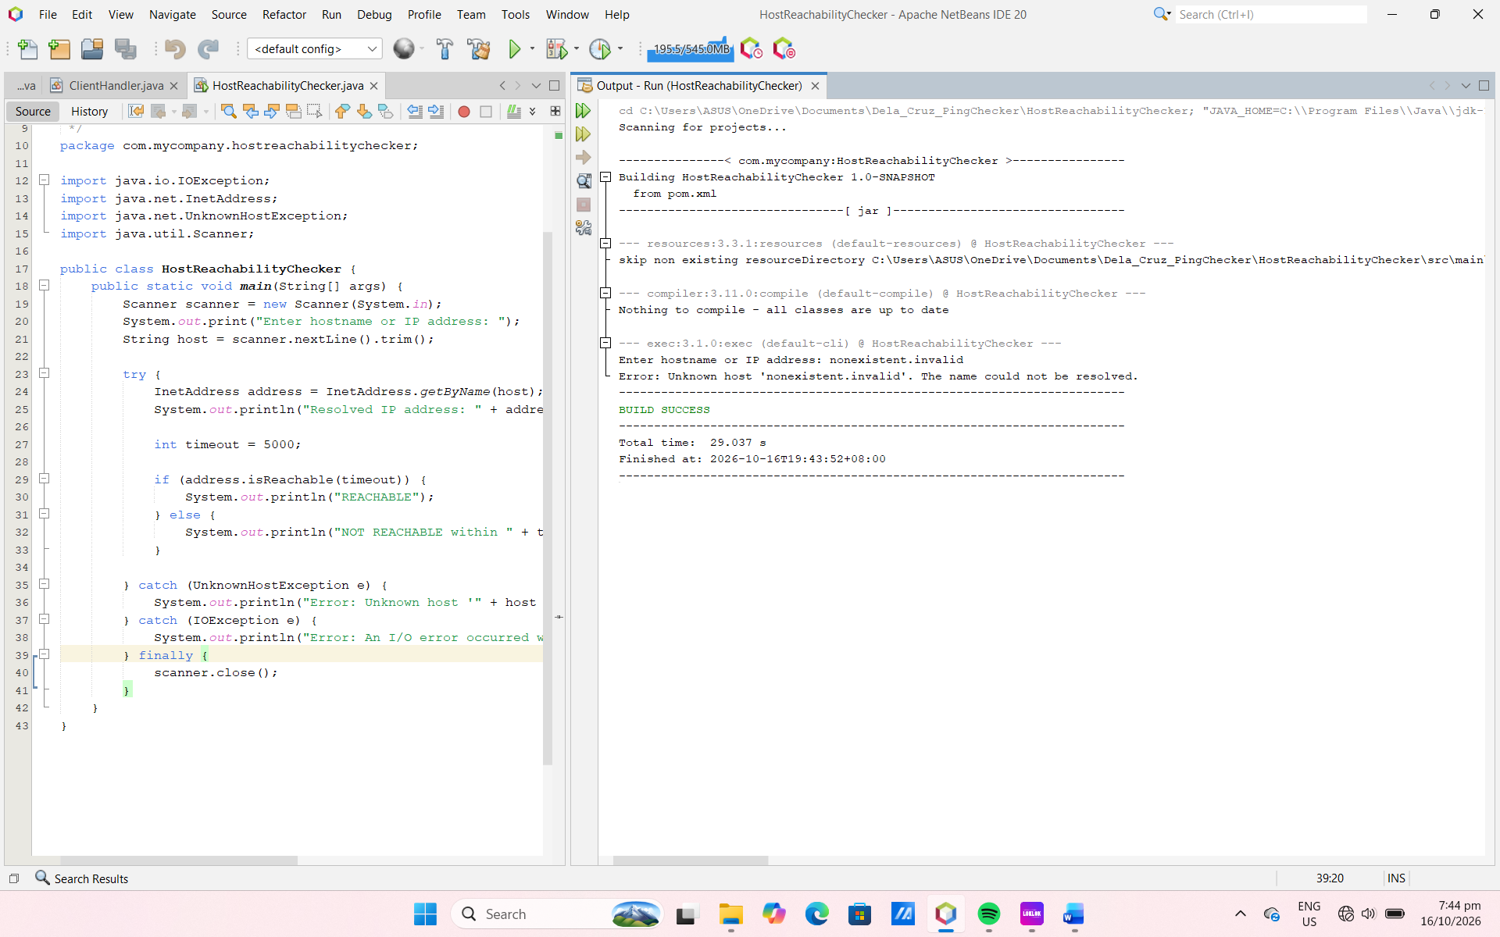
TEST 4

Part C: Explanation of Findings & Supervisor Update

- Why is InetAddress.getByName() called before isReachable()? Which test demonstrated a name resolution error?

- InetAddress.getByName() is called first to translate a human-readable hostname into a numeric IP address required for network communication. Test 4 (nonexistent.invalid) demonstrated a name resolution error because it failed at this initial DNS lookup stage before any reachability packet could be sent.

- What does the value 5000 represent? Why should a network checking program use a timeout?

- The value 5000 represents 5000 milliseconds (or 5 seconds), which sets the maximum time threshold the program will wait for a response. A network checking program must use a timeout to prevent the application from freezing indefinitely if a target host is down, unresponsive, or dropping packets.

- How does an unknown host error differ from a NOT REACHABLE result after an IP address was resolved?

- An unknown host error means the system failed to translate the name into an IP address (a DNS failure). A NOT REACHABLE result means name resolution was successful, but the target IP address did not respond within the 5000 ms window (due to routing issues, firewalls, or the device being offline).

- Why can this Java checker report NOT REACHABLE even when a computer is running? Explain how ICMP relates to ping and give one reason Java and the operating system ping command may produce different results.

- The operating system's native ping command typically relies on ICMP (Internet Control Message Protocol) echo requests, which routers and firewalls are often configured to allow. In contrast, Java’s InetAddress.isReachable() implementation often attempts a TCP port 7 (Echo) connection depending on security privileges and OS constraints, which firewalls frequently block. Thus, a computer can be fully functional and online, yet appear NOT REACHABLE in Java because the specific port or check type was restricted.

- Write a three to five sentence update to your campus IT supervisor. State which targets you tested, summarize the results, and recommend one next step. Avoid concluding that a service works solely because its host is reachable.

- For this activity, I tested the Java reachability tool using localhost, the IPv4 loopback address (127.0.0.1), an assigned campus network target, and the invalid domain nonexistent.invalid. The local loopbacks responded successfully, and the invalid entry properly handled the unknown host error without crashing. Although the campus target was evaluated within the 5000 ms timeout window, we should avoid concluding that a service functions fully just because its host is reachable. As a next step, I recommend performing application-level checks alongside these network diagnostics to confirm true service availability.

